Gavin Roberts enjoys an extraordinarily varied career as a pianist, organist, conductor, director and coach. He has appeared at venues and festivals in the UK and abroad including Barbican Hall, Wigmore Hall, The Royal Festival Hall, Oundle International Festival, Dartington International Festival, The Ludlow Weekend of English Song, The Ryedale Festival, Oxford International Song Festival. He is a professor and staff pianist at the Guildhall School of Music & Drama and is the Artistic Director of Song in the City.

Gavin has collaborated with numerous singers, conductors, instrumentalists and ensembles including Lucy Hall, Andrew Watts, Rosamund Shelley, Madeleine Holmes, Eleanor Rolfe Johnson, Donna Lennard, Amanda Pitt, Carolyn Sampson, Robin Tritschler, Ailish Tynan, Jess Dandy, Samantha Crawford, David Greco, Gareth Brynmor John, Angus Meryon, Alan Hacker, Clare Hoskins, Libby Burgess, Graham Johnson, Roger Norrington, Richard Hicox, The BBC Singers, The BBC Symphony Chorus, The Academy of Ancient Music, The National Youth Choir, Schola Cantorum of Oxford, The Joyful Company of Singers, Constanza Chorus, Kingston Choral Society and Fulham and Hammersmith Choral Society, often appearing on radio broadcasts and recordings. Recent highlights include a recital of songs by Lili Boulanger in Antwerp with regular recital partner soprano Lucy Hall, and a performance in the Monodrama Festival, Luxembourg with countertenor Andrew Watts.

Gavin is an experienced and creative concert programmer, including five successful seasons as Artistic Director of The St Marylebone Festival. His work is often characterised by collaborations with other artistic disciplines. Recent work includes a choreographed performance of Schubert’s Wintereise at Rambert, a London Fashion Week show for designer Patrick McDowell at Guildhall School, and a Welsh tour of Novello & Son with Rosamund Shelley. He has been Artistic Director of Song in the City since 2011 for which he has devised more than 150 concerts often on socially-engaged themes, and has pioneered ‘Creative Minds in Song’ commissioning composers to create new songs on the poems of mental-health service users. Passionate about working with composers he has given numerous premieres of new works, as well as composing a small number of works himself. A recent project was a recording of London-themed song commissions ‘Voices of London’ for Song in the City by composers Raymond Yiu, Joseph Atkins, James Lark and Graham Ross.

Gavin was Organist and Director of Music at St Marylebone Parish Church from 2014-2022. He gained a Masters (distinction) in piano accompaniment from Guildhall School, and previously read Music and held the organ scholarship at Gonville and Caius College, Cambridge, and a Master’s degree (distinction) from King’s College London. He is a Fellow of the Royal College of Organists and a Trustee of The Finzi Friends.

More details: www.gavinroberts.org & www.songinthecity.org

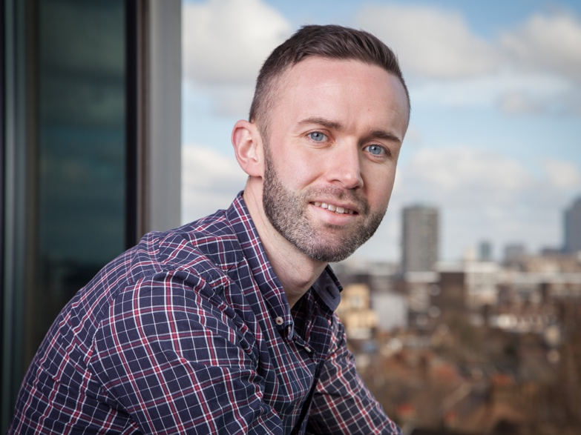
Credit: Felipe Tozzato

